(Approx. 1184 words)

Apps - By Google, by gosh
By Phil Sorrentino, Contributing Writer, The Computer Club, Florida
The Journal of The Computer Club, Inc.
http://scccomputerclub.org / Philsorr.wordpress.com
philsorr (at) yahoo.com

Most of us know Google as a website we visit to get answers to all kinds of questions, but there is a lot more behind the company and the term Google. Google is a company, a website, a number, and a verb. The company, Google, began as a Research Project in 1996 to develop a Search Engine for web pages, and was incorporated in 1998. Google, the company, is currently valued at over $82 billion. The Google website, which searches and prioritizes other websites, is available in 123 languages and has over 4.5 billion active users. Google, the number (actually Googol), is 1 followed by one hundred zeros or 10 raised to the 100th power. And Google, the verb, was first added to the dictionary in 2006.

But enough esoterica, we want to explore the Google computer Apps that can help us in our daily digital life. So, let me list many of them, and then we can delve further into a few that are very useful. There is, obviously, Google Search, and Gmail, Calendar, YouTube, Google Drive, Google Maps, Google Docs, Photos, Translate, Keep, News, Books, Shopping, Finance, and others. And all of these can be accessed through the Google website, just by clicking on the “All Apps” button on your laptop or desktop computer

 All Apps
or, if they didn’t come pre-installed on your mobile device, by downloading them from the Google Play Store.
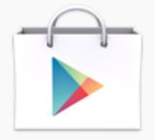 Google Play Store

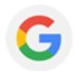 Google Search
Google Search probably needs the least introduction because it has been around the longest, and we have had it almost from the beginning of our use of the internet. Google Search answers our questions, not with answers, but by providing an ordered list of websites that will, hopefully, answer our question. We then go to these websites with expectations of finding the answer, and most of the time we do. (Google Search’s magic is really done long before we ask our question. It “crawls the web” 24/7, finding and ordering websites so that they can be suggested as places to find the answer, when we ask the question.) So, Google Search is really sewn into the fabric of our digital life, as evidenced by the fact that every time we need an answer, we think or say “just Google that”.

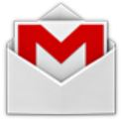 Gmail
Gmail is probably the second best know Google App. Gmail is a free, advertiser supported web based Email service that came out of beta in 2009 and currently provides its users with 15GB of email storage space. It allows the user to send Emails (with attachments) of up to 25MB to any known Email address. And it will receive Emails (with attachments) of up to 50MB. Gmail currently has over 1 billion Active users worldwide. Gmail is a great place to keep all your contact information which is then available to your smartphone while you’re on the go.

 Calendar
Google Calendar is a free time management and scheduling, web based, App. It allows the user to create and edit calendar events with start and stop times, which are then viewable by day, week, or month, on your computer or your smartphone. Google Calendar lets you combine multiple calendars including those for holidays and birthdays. The Calendar App on your smartphone can then help you answer the question, “Can you make an appointment three weeks from today, at 1 o’clock?” Just pull out your smartphone, start calendar, and all of your previously scheduled appointments will be shown, so you don’t “double book” a time.

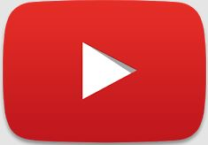 YouTube
YouTube, not originally invented by Google, but bought for over $1.6 billion in 2006, is a free Video Sharing website. Registered users can upload video clips, TV show clips, music videos, movie trailers, etc. to the site and unregistered users can watch whatever is on the site. There are instructional videos for just about everything. Try it the next time you want to change the air filter in your car, or need to see a different cooking technique, or want to know more about Windows 10. Beyond education, there are many just downright entertaining videos available, with subjects like kids, puppies, kittens, and ponies.

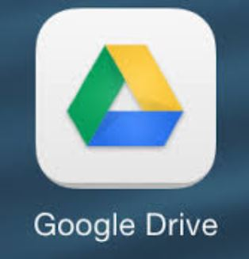 Google Drive
Google Drive is a free cloud storage service with over 1 million users. It allows the user to store files on the Google Drive servers (in the cloud) and synchronize, or not synchronize, those files with all the user’s devices. (File synchronizing (or syncing) is the process of ensuring that files on two or more devices are kept updated.) Google Drive provides 15GB of free storage and the files stored can be accessed by both your computer and your smartphone. And for Android smartphones, Google Drive has added a feature that lets you easily scan a document and upload it to Google Drive.

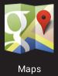 Google Maps
Google Maps is a Web based Mapping service that provides Satellite and Aerial imagery of almost any place on the globe; it also provides Street Maps of most populated areas. For certain cities, there are 360-degree Panoramic Street Views. It also provides directions and route planning capabilities for car, walking, and bicycling. The mobile App is available for Android and iOS and provides a turn-by-turn navigation capability.

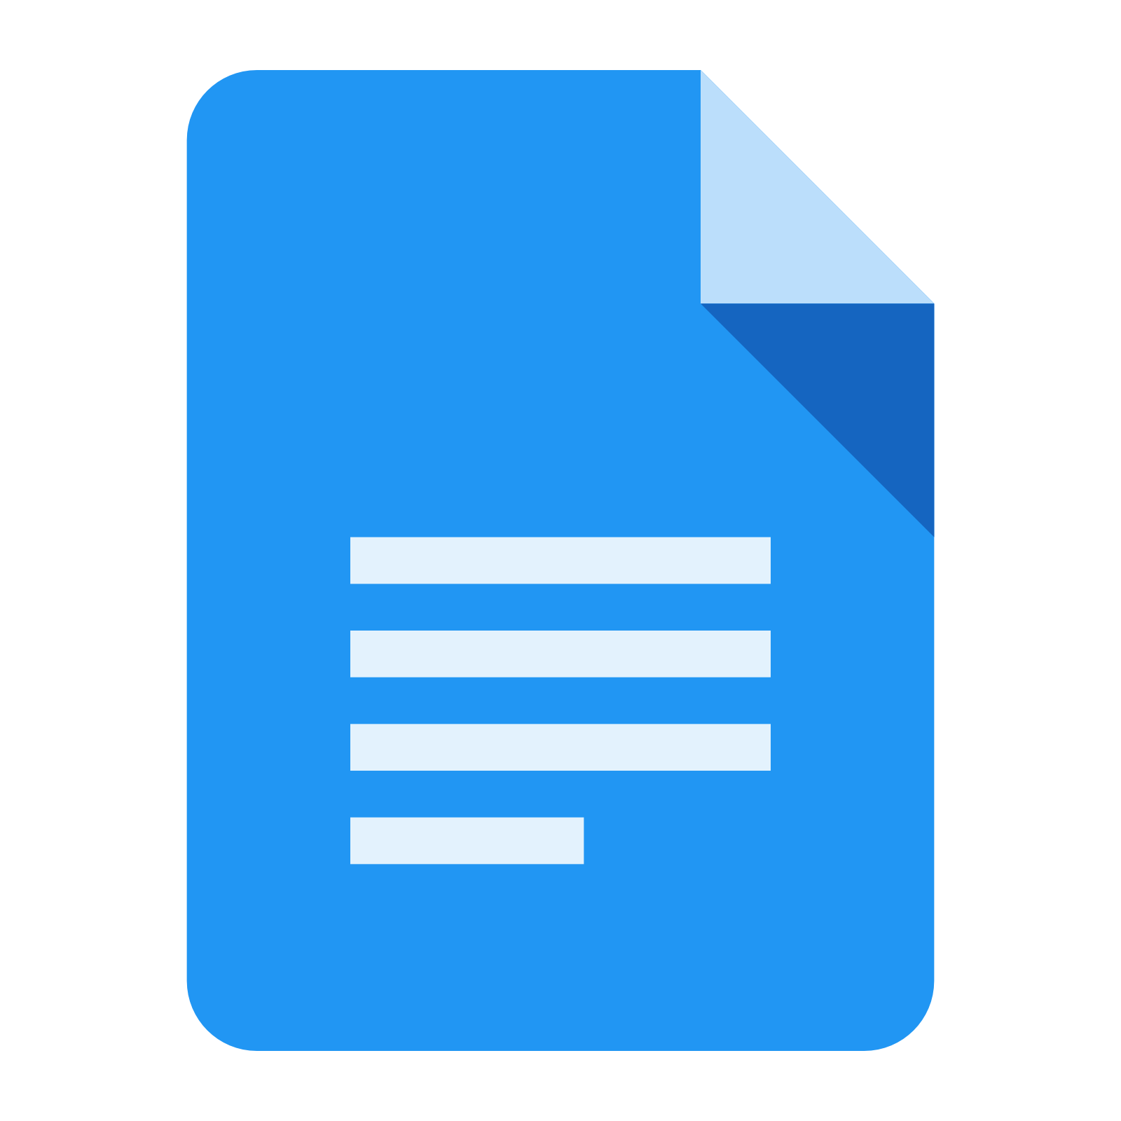 Google Docs
Google Docs is a Free Web Based Suite of Office Applications. It includes a Word Processor, a Spreadsheet App, and a Presentation App. It allows the user to create and edit files online, and collaborate with other users. The files produced are compatible with Microsoft Office file formats. Google Docs is tightly integrated with Google Drive in that all files created by the Apps are by default saved on Google Drive. Mobile Apps are available for Android and iOS.

 Google Photos
Google Photos, which was launched in 2015, is not only a Photo Viewer App, it is also a Storage and Sharing Service. It provides free unlimited storage, in the cloud, for pictures up to 16 megapixels in size and videos up to 1080p resolution. It analyzes photos identifying various visual features and subjects. Users can then search for photos based on People, Places, or Things. (Google Photos has two storage settings: “High Quality” and “Original Quality”. High Quality provides the aforementioned qualities. Original Quality preserves the original size of the photos and resolution of videos if they were higher than High Quality, but subtracts these from the users’ Google account storage allocation.) 200 million users have uploaded over 13.7 petabytes of photos and videos. (Remember a petabyte is 1,000 terabytes and a terabyte is 1,000 gigabytes, so 1 petabyte = 1,000,000 gigabytes.)

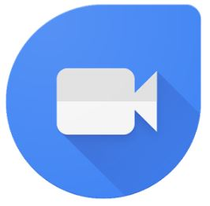 Google Duo Google Waller
Google provides many more services including a Video Conferencing App for smartphones, called Duo, that will finally let an Android phone video conference with an Apple iPhone; and Google Wallet, which lets you transfer money to another person with no cost to the sender or receiver. As you can see, Google certainly has a substantial presence in our digital daily activities.

